SAMPLE EVENTBRITE REGISTRATION PAGE (VICTORIA PILOT)
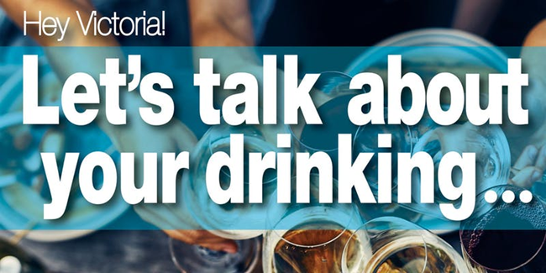

DESCRIPTION
You’re invited to an engaging Community Dialogue!
You’ll hear from speakers about the business, health and the culture of alcohol, and engage with others in a workshop setting to talk about one of society’s biggest pastimes.
Join us for a freewheeling conversation to explore Victoria’s favourite legal drug and unpack our drinking culture: why people love it, and the myths and evidence on how it affects our health, our communities, and our economy.
Speakers include:
* Dr. Richard Stanwick, Chief Medical Health Officer for Island Health
* Rod Phillips, Co-Founder at Liquify.ca and Radio Show Host at The Dork UnCorked
* Dan Reist, Assistant Director of Knowledge Exchange, The Canadian Institute for Substance Use Research (CISUR) at Uvic
CLICK HERE for full presenter bios!
What is this all about?
This event is part of a series of Vital Conversations connected to important issues and trends identified in Victoria’s Vital Signs,our community’s annual check-up.
Hosted by Victoria Foundation, in collaboration with the Community Action Initiative, this community dialogue is aimed at fostering open conversation across sectors and perspectives about one of our society’s biggest pastimes. Collectively we'll dig in to the perceptions, evidence, opportunities and challenges related to moderate drinking in our community. Feedback will be used to help create additional convening opportunities, as well as provide people and organizations with information that promotes healthy choices and reduces the risks of moderate drinking.

What will this conversation focus on?
This Vital Conversation will focus on the experience of moderate drinking and its effects on our community. It is NOT about high risk, heavy-drinking, binge-drinking, chronic substance abuse or alcoholism. While these are indeed all important community concerns worthy of conversation, they are not the emphasis of this dialogue.

Who should attend?
This Vital Conversation is open to all community members, and we welcome diverse perspectives and sectors to join us, including:
Interested community members
Local businesses
Liquor producers and retailers
Restaurant and tourism industry
Community-based organizations
Health sector
Policy makers and government
Law enforcement
Researchers
Schools & Educators
Neighbourhood associations

What to expect:
Great conversation, interesting speakers, and some delicious appies! You’ll hear from speakers about the business, health and the culture of alcohol, and engage with others in a workshop setting. Here’s an overview:
3:00 “Mocktail” Reception, Registration & Introductions
3:30 Welcome & Setting the Context
3:55 Introductory Small Group Dialogue
4:20 Speakers Panel & Discussion
5:05 Small Group Dialogue
5:45 Share back & Plenary Discussion
6:30 Close

Did you know?
- The average person on Southern Vancouver Island consumed the equivalent of 689 bottles of beer or 131 bottles of wine in 2016
- Alcohol sales contributed over $1 billion to BC’s income last year
- As little as one drink per day has been linked to increased risk of certain types of cancer
- Alcohol has played a central role in almost all human cultures since the Stone Age

